CEL 51, DCCN, Monsoon 2020

Lab 6: Subnet and Router Configuration

## Topology Diagram

## 

## Addressing Table

|  |  |  |  |  |
| --- | --- | --- | --- | --- |
| **Device** | **Interface** | **IP Address** | **Subnet Mask** | **Default Gateway** |
| **R1** | **Fa0/0** | 192.168.1.33 | 255.255.255.224 | **N/A** |
| **S0/0/0** | 192.168.1.65 | 255.255.255.224 | **N/A** |
| **R2** | **Fa0/0** | 192.168.1.97 | 255.255.255.224 | **N/A** |
| **S0/0/0** | 192.168.1.94 | 255.255.255.224 | **N/A** |
| **PC1** | **NIC** | 192.168.1.62 | 255.255.255.224 | 192.168.1.33 |
| **PC2** | **NIC** | 192.168.1.126 | 255.255.255.224 | 192.168.1.97 |

## Learning Objectives

Upon completion of this lab, you will be able to:

* Subnet an address space given requirements.
* Assign appropriate addresses to interfaces and document.
* Configure and activate Serial and FastEthernet interfaces.
* Test and verify configurations.
* Reflect upon and document the network implementation.

## Scenario

In this lab activity, you will design and apply an IP addressing scheme for the topology shown in the Topology Diagram. You will be given one address block that you must subnet to provide a logical addressing scheme for the network. The routers will then be ready for interface address configuration according to your IP addressing scheme. When the configuration is complete, verify that the network is working properly.

**Task 1: Subnet the Address Space.**

**Step 1: Examine the network requirements.**

You have been given the 192.168.1.0/24 address space to use in your network design. The network consists of the following segments:

* The network connected to router R1 will require enough IP addresses to support 15 hosts.
* The network connected to router R2 will require enough IP addresses to support 30 hosts.
* The link between router R1 and router R2 will require IP addresses at each end of the link.

**Step 2: Consider the following questions when creating your network design.**

How many subnets are needed for this network? **3**

**Ans) 3 subnets will be needed as three networks are formed**

1. **Network connected to R1**
2. **Network connected to R2**
3. **Link between R1 and R2**

What is the subnet mask for this network in dotted decimal format? **255.255.255.224**

**Ans) 192.168.1.0/24 is a Class C network because the first octet 192 falls in the class C network range**

**Class C network has a default subnet mask of 11111111.11111111.11111111.0**

**The first three octets are dedicated to network and they never change**

**The remaining 1s in the subnet mask has to be our subnet bits**

**3 bits are required for subnets so there will be 3 1s in the final octet**

**So, the binary form of the subnet mask is 11111111.11111111.11111111.11100000**

**Converting to dotted-decimal form,**

**The subnet mask is 255.255.255.224**

What is the subnet mask for the network in slash format? **/27**

**Ans) It is the total number of ones in the binary form of the subnet mask**

**So, the subnet mask in slash format is /27**

How many usable hosts are there per subnet? **30**

**Ans) Using the hosts formula,**

**h = number of zeroes in the binary form of subnet mask = 5**

**Usable hosts = 2h - 2 = 25 - 2 = 30 hosts**

**Step 3: Assign sub-network addresses to the Topology Diagram.**

1. Assign subnet 1 to the network attached to R1.
2. Assign subnet 2 to the link between R1 and R2.
3. Assign subnet 3 to the network attached to R2.

**Task 2: Determine Interface Addresses.**

**Step 1: Assign appropriate addresses to the device interfaces.**

1. Assign the first valid host address in subnet 1 to the LAN interface on R1.

192.168.1.33

1. Assign the last valid host address in subnet 1 to PC1.

192.168.1.62

1. Assign the first valid host address in subnet 2 to the WAN interface on R1.

192.168.1.65

1. Assign the last valid host address in subnet 2 to the WAN interface on R2.

192.168.1.94

1. Assign the first valid host address in subnet 3 to the LAN interface of R2.

192.168.1.97

1. Assign the last valid host address in subnet 3 to PC2.

192.168.1.126

**Step 2: Document the addresses to be used in the table provided under the Topology Diagram.**

**Task 3: Configure the Serial and Fast Ethernet Addresses.**

**Step 1: Configure the router interfaces.**

Configure the interfaces on the R1 and R2 routers with the IP addresses from your network design. Please note, to complete the activity in Packet Tracer you will be using the Config Tab. When you have finished, be sure to save the running configuration to the NVRAM of the router.

Network devices

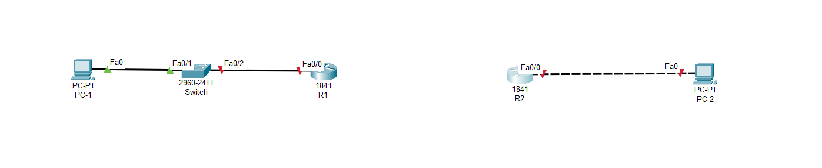

Adding Serial Ports to Routers

1. Turn Router off in Physical Tab
2. Click on HWIC-2T tab and drag Cisco HWIC-2T 2-Port Serial WAN Interface Card to router then turn router on

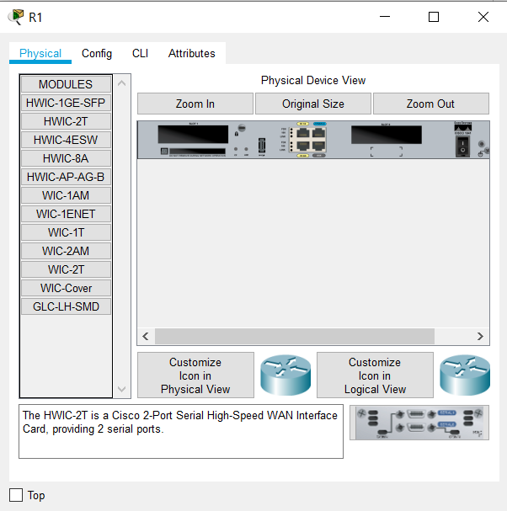

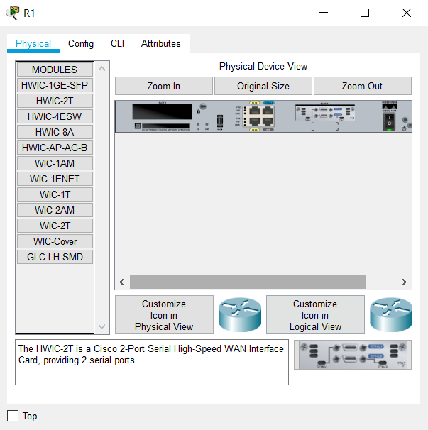

Similarly, 2 serial ports are added to R2

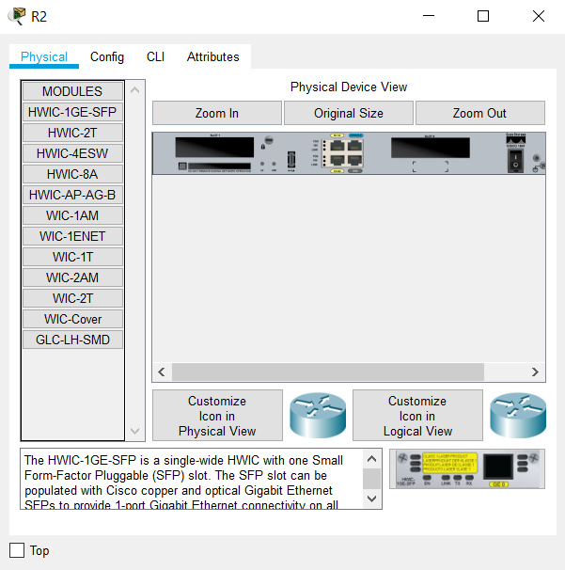

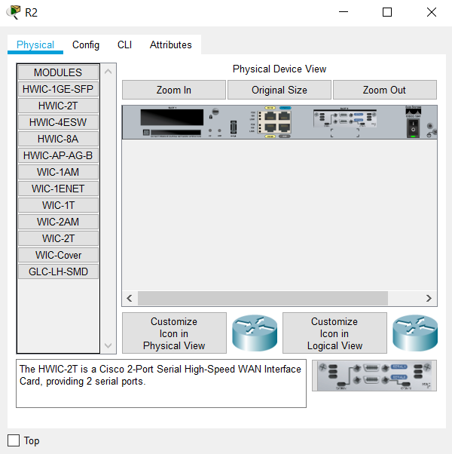

Now, we can connect R1 and R2 using DTE

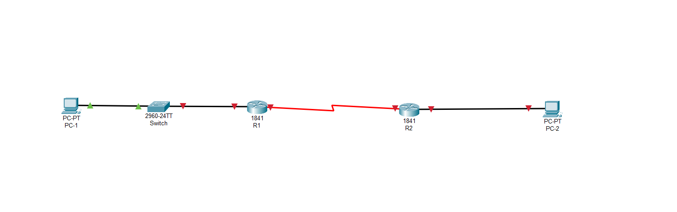

**Router Configuration**

Interface Fa0/0 of R1

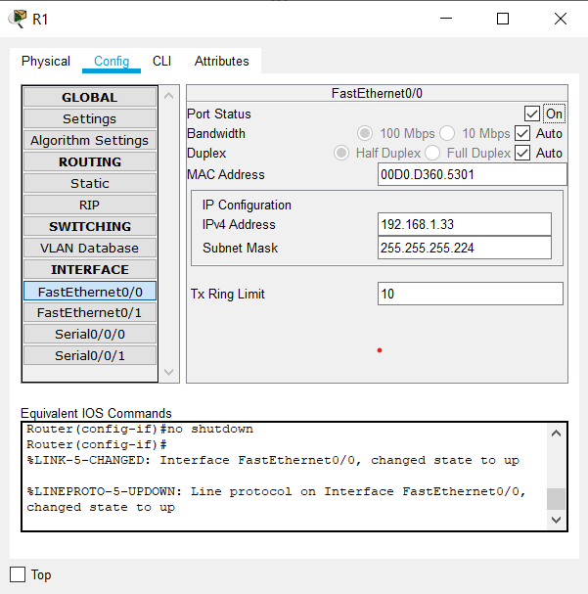

Interface S0/0/0 of R1

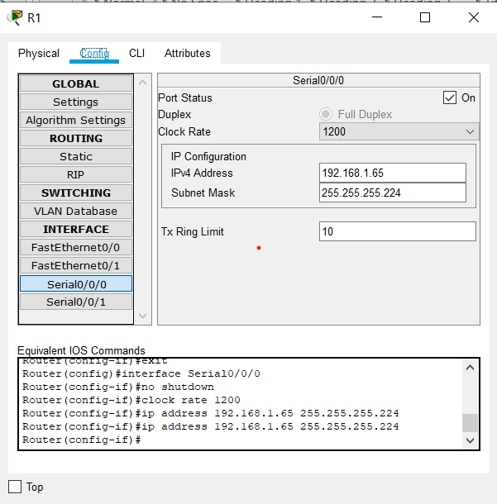

Interface Fa0/0 of R2

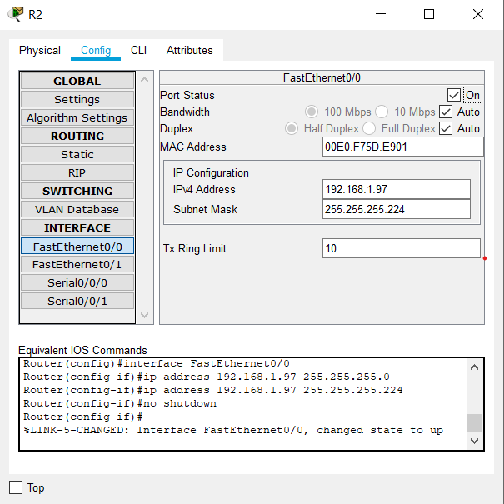

Interface S0/0/0 of R2

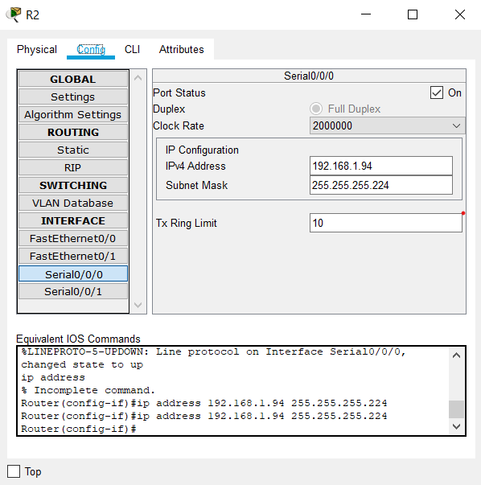

**Step 2: Configure the PC interfaces.**

Configure the Ethernet interfaces of PC1 and PC2 with the IP addresses and default gateways from your network design.

Interface Fa0/0 of PC1

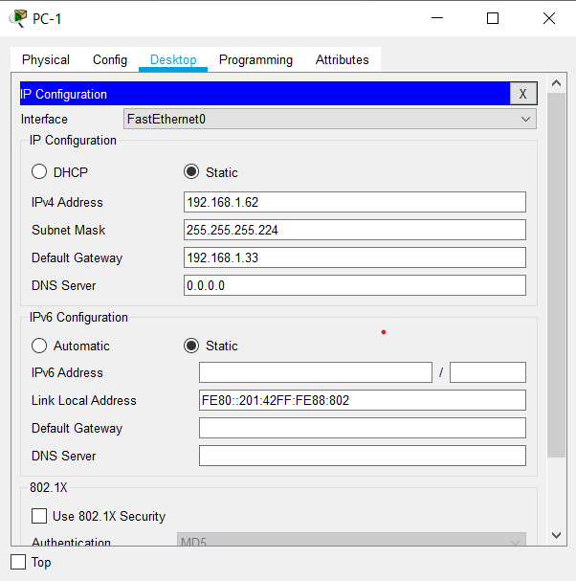

Interface Fa0/0 of PC2

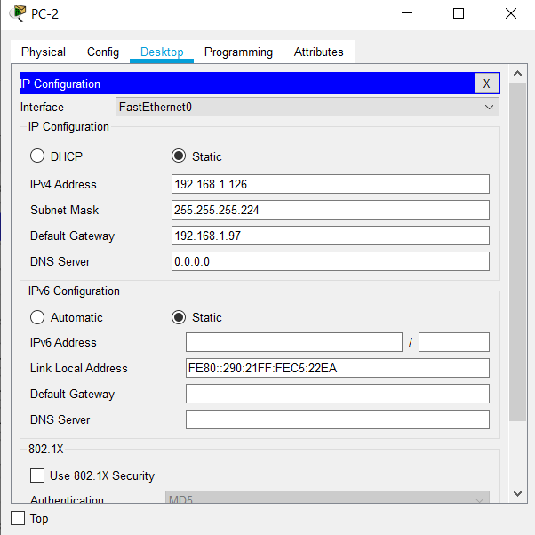

Final Network

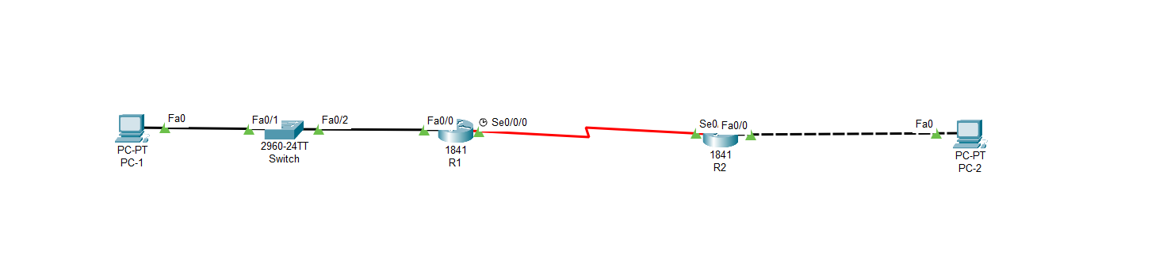

Save the running configuration to the NVRAM of the router

Initially, the routers have no startup-config

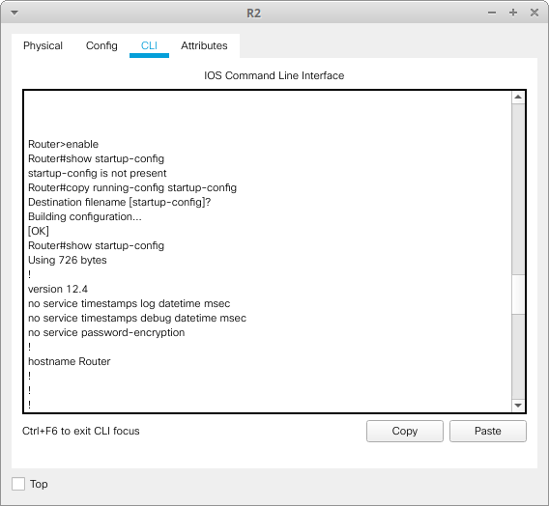

Saving running-config as startup-config

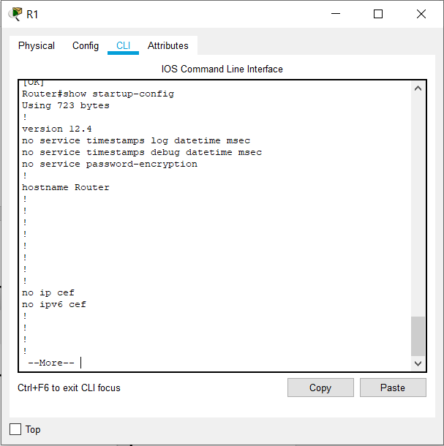

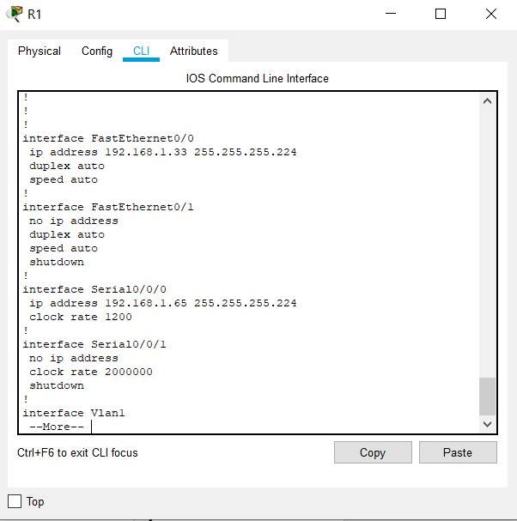

The startup-config shows the running-config details as expected

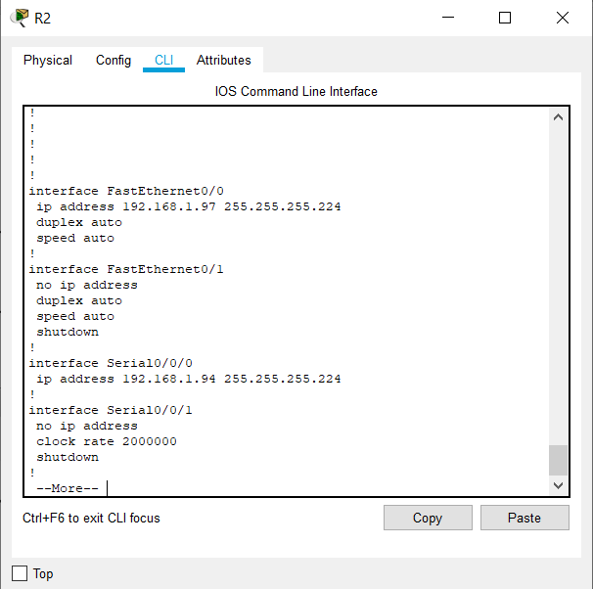

**Task 4: Verify the Configurations.**

Answer the following questions to verify that the network is operating as expected.

From the host attached to R1, is it possible to ping the default gateway? yes

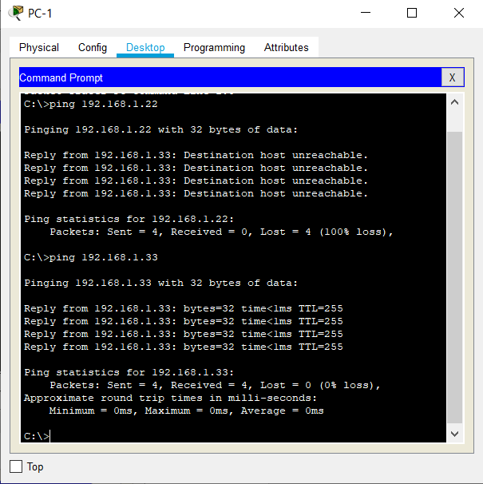

From the host attached to R2, is it possible to ping the default gateway? yes

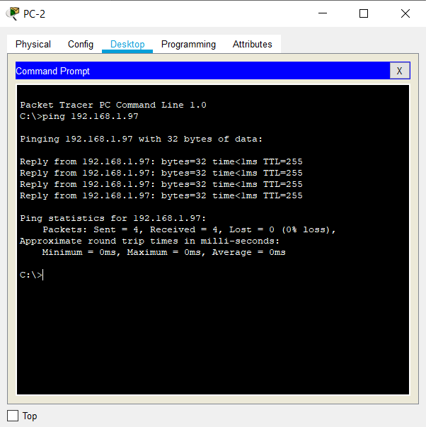

From the router R1, is it possible to ping the Serial 0/0/0 interface of R2? yes

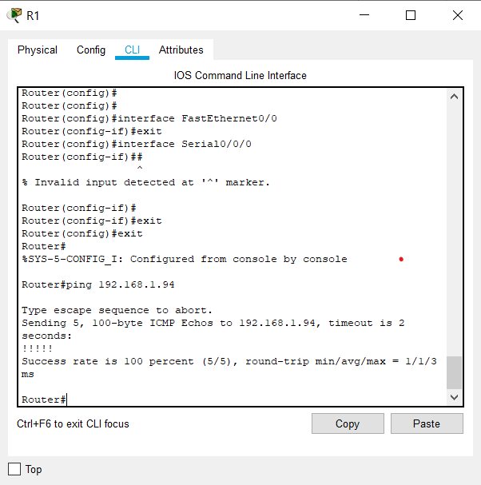

From the router R2, is it possible to ping the Serial 0/0/0 interface of R1? yes

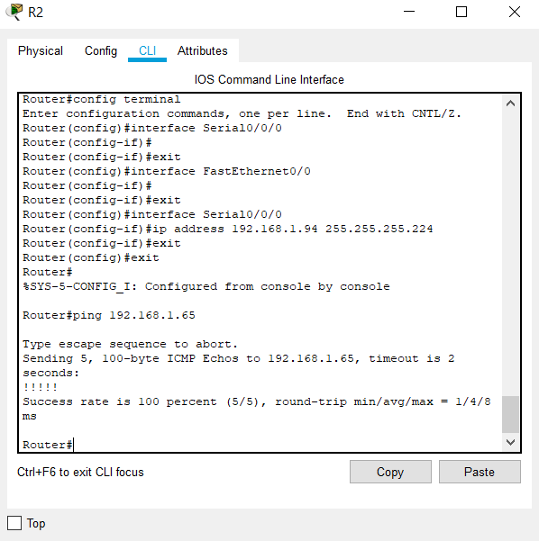

The answer to the above questions should be **yes**. If any of the above pings failed, check your physical connections and configurations.

**Task 5: Reflection**

Are there any devices on the network that cannot ping each other?

Yes, devices that are not a part of the same network cannot ping each other. For example, PC1 and PC2 cannot ping each other

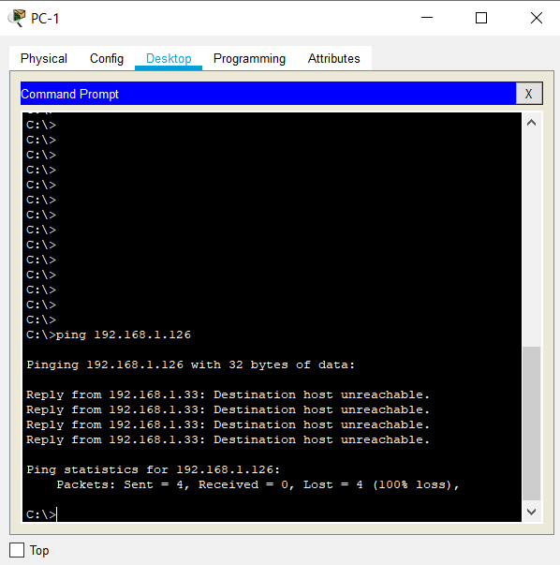

What is missing from the network that is preventing communication between these devices?

Ans: We have to configure routing, either static or dynamic in order to establish communication.